***ADDS UP TO***

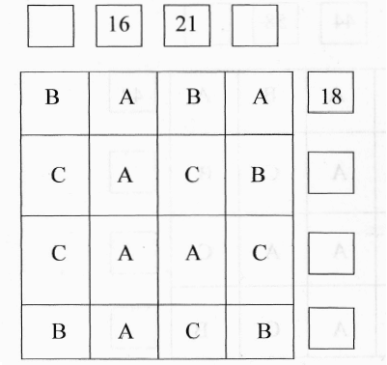In this diagram the letters A, B and C represent different numbers. The columns and rows add up to the numbers shown.

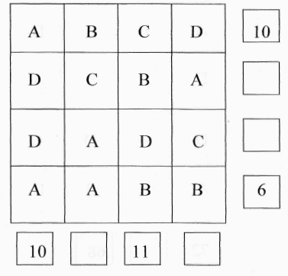Find the values of the letters.

In this diagram the letters A, B, C and D represent different numbers. The columns and rows add up to the numbers shown.

Find the values of the letters

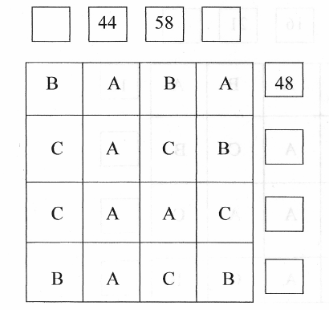

In this diagram the letters A, B and C represent different numbers.

The columns and rows add up to the numbers shown.

Find the values of the letters.

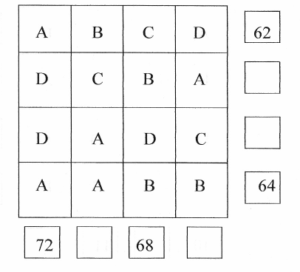In this diagram the letters A, B, C and D represent different numbers.

The columns and rows add up to the numbers shown.

Find the values of the letters